DEMOGRAPHICS

Name: _______________________________________________________________________________________
(Last Name) (First Name) (Middle Initial)

Address: _____________________________________________________________________________________

Apt/Ste: ____________ City: ___________________________ State: ________ Zip code: _________________

Contact Number: ___________________________________

Email: _______________________________________________________________________________________

Date of Birth: _____________________________ Age: __________ Male Female

Patient Employer/School:_______________________________________________________________________

Occupation: _________________________________________________________________________________

SSN#: _________-_______-___________

Please circle one:
Married Widowed Single Domestic Partnership
Divorced Separated Minor

Emergency Contact Name: _____________________________________________________________________

Relation: ____________________________________________________________________________________

Emergency Contact Phone Number: ______________________________________________________________

Who may we thank for referring you? ____________________________________________________________

PATIENT CONDITION

Please circle the reason for your visit: Chiropractic Massage Both

When did symptoms appear? ___________________________________________________________________

How often? _________________________________________________________________________________

Does it interfere with your: Work Sleep Routine Recreation

Which are painful to perform: Sitting Standing Walking Bending Laying Down

Treatments Received:
Medications Surgery Physical Therapy Chiropractic Massage
Other: _______________________________________________________________________________________

Are you pregnant? Yes No Due Date: __________________________________________________

ACCIDENT INFORMATION

Is condition due to an accident? Yes No Date of accident: __________________________________

Type of accident: Auto Work Home Other: __________________________________________

To whom have you made a report of your accident / Are you opening a claim?
Auto Insurance Company / PIP Employer Worker Comp / L&I Other: __________________________

If applicable:
Attorney Name: ________________________________________ Contact Number: ______________________
Insurance Company: _____________________________________ Claim Number: __________________________
Claim Adjuster: _________________________________________ Contact Number: ________________________

HEALTH HISTORY

Please circle if any of the following apply to your current or past history:

AIDS/HIV Alcoholism Allergy Shots Anemia Anorexia
Anxiety Appendicitis Arthritis Asthma Athlete’s Foot Bleeding Disorders Bone/Joint Disease Bronchitis Bulimia Cancer Cataracts Chemical Dependency Chicken Pox Chronic Pain Depression
Diabetes Emphysema Epilepsy Fractures Glaucoma Goiter Gonorrhea Gout Heart Disease Hepatitis Hernia Herniated Disc Herpes High Blood Pressure High Cholesterol Kidney Disease Liver Disease Lupus Measles Migraine Headaches
Miscarriage Mononucleosis Multiple Sclerosis Mumps Osteoporosis Pacemaker Paralysis Parkinson's Disease Pinched Nerve Pneumonia Polio Prostate Problem Prosthesis Psychiatric Care Rheumatoid Arthritis Rheumatic Fever Scarlet Fever Shingles STD/STV Spinal Problems
Stroke Suicide Attempt Tendinitis Thyroid Problems Tonsillitis Tuberculosis Tumors/Growths Typhoid Fever Ulcers Vaginal Infections Whooping Cough

Other: ________________________________________________________________________________________

Allergies/Sensitivities: ___________________________________________________________________________
_____________________________________________________________________________________________

Medications: __________________________________________________________________________________
_____________________________________________________________________________________________

Past Injuries/Surgeries: __________________________________________________________________________
_____________________________________________________________________________________________

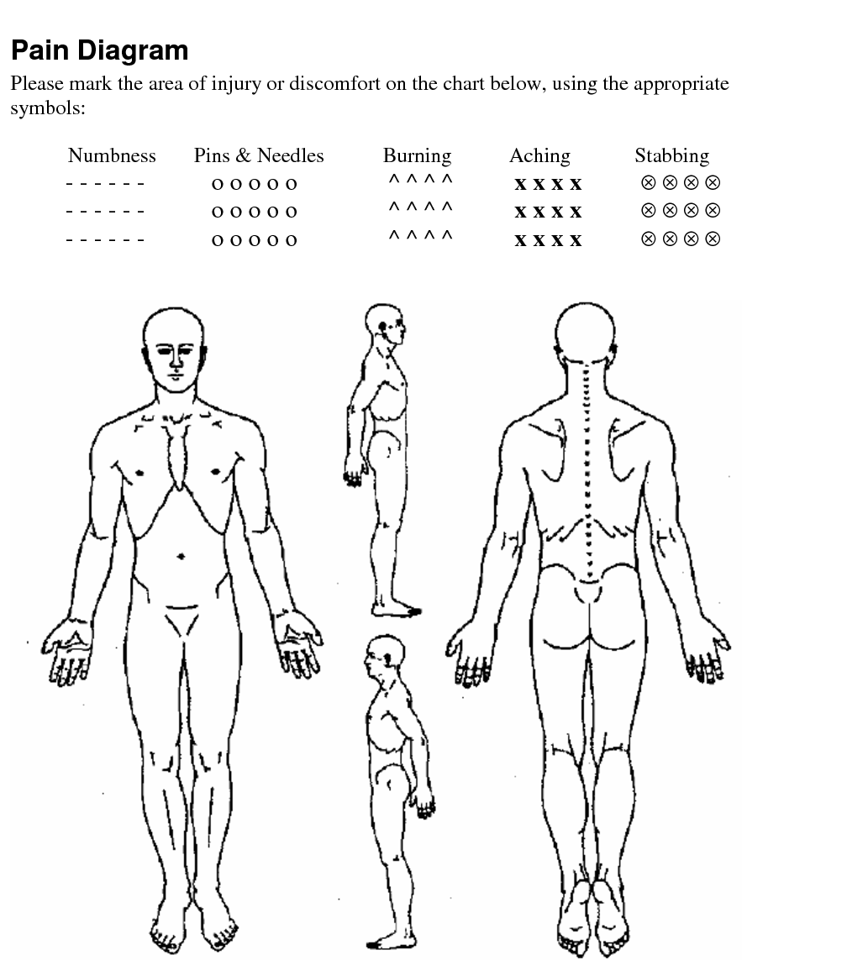

Policies & Procedures

Appointments: A certain number of adjustments in a given time period is necessary to get the best results from your care and create wellness in your life. While we cannot predict the exact number of adjustments you will need, we do know that consistency creates the best results. Therefore, it is absolutely necessary that you keep your scheduled appointments. If you need to change an appointment, please call at least 24 hours in advance to reschedule your appointment. We will do all that we can to accommodate you.

*For Massage Appointments Only - If you fail to cancel with 24 hours’ notice, there will be a $50 late cancellation fee applied to your account.

Daily Visit Procedure:
Each time you arrive for your appointment, check in at the front desk and we will instruct you what to do next. Once the Doctor learns your spine, your adjustments will take only a few minutes and will be very focused. It may be necessary for you to rest after an adjustment has been made. The length of your resting time may vary and will be determined at the time of your adjustment.

Analysis/Examinations/Treatment:
During your Initial Intensive Care, you will receive several examinations to monitor your level of spinal correction. All the findings from your initial visit will be re-tested. Plan on spending approximately 30 minutes on these days. At the end of your Initial Plan of Care, you will receive recommendations for additional care to help you stay as healthy as possible.

As part of the analysis, examination and treatment, you are consenting to the following procedures:

Spinal Adjustment Therapy Orthopedic Testing Muscle Strength Testing Range of Motion Testing Postural Analysis Vital Signs Radiographic Studies Cold Therapy
Basic Neurological Testing Palpitation

We do not offer to diagnose or treat any disease or condition other than Vertebral Subluxation. However, if during the course of a Chiropractic examination, we encounter non-Chiropractic or unusual findings, we will advise you. If you desire advice, diagnosis or treatment for those findings, we will recommend that you seek the services of a Health Care Provider that specializes in that area.

Payment:
We will bill directly to your insurance if your policy covers Chiropractic Care or Massage Therapy. Any Coinsurance or Copayments estimated by your insurance to us will be collected at the time of service. You are responsible for your portion of insurance payments along with anything that is denied by your insurance. We offer several different methods of payment and are happy to work out payment options with you.

I, _________________________________, have read and fully understand the above statements.
(Print Name)

All questions regarding the Doctor's objectives pertaining to my care in this office have been answered to my satisfaction. I therefore accept Chiropractic Care (and/or) Massage Therapy on this basis.

_________________________________________________ ______________________________
(Patient or Guardian's Signature) (Today's Date)

Notice of HIPAA Practices

This notice describes how medical information about you may be used and disclosed and how you can get access to this information. Please review carefully

We understand that your medical and health information is personal. Protecting your health information is important. We follow strict federal and state laws that require us to maintain the confidentiality of your health information. When you receive care from us, we may use your health information for treating you, billing for services, and conducting our normal business known as health care operation. Examples of how we use your information include:

Health Care Operations:
We use your health information to improve the quality of care, train staff, provide customer service, manage costs, conduct required business duties, and make plans to better serve our patients.

To use your health information for other than the above uses require your signed authorization.
There are limited situations when we are permitted or required to disclose health information without your signed consent.

These situations include:
- For public health purposes such as reporting communicable diseases, work-related illnesses, or other diseases and injuries permitted by law; reporting births and deaths; and reporting reactions to drug problems with medical devices.
- To protect victims of abuse, neglect, or domestic violence.
- For health oversight activities such as investigations, audits, and inspections.
- When otherwise required by law, for lawsuits and similar proceedings, or when requested by law enforcement as required by law or court order.
- To coroners, medical examiners, and funeral directors.
- To reduce and prevent a serious threat to public health and safety.

We are required by law to:
- Maintain the privacy of your health information.
- Provide this notice that describes the ways we may use and share your health information.
- Follow the terms of the notice currently in effect.
- We reserve the right to make changes to this notice at any time and make the new privacy practices effective with all the information we maintain. You may request a copy of any notice from our Privacy Officer.

You have the right to:
- Request restrictions on how we use and share your health information. We will consider all requests for restrictions carefully but are not required to agree to any restrictions.
- Request that we use a specific telephone number or address to communicate with you.
- Inspect and copy your health information, including medical and billing records. Fees may apply. Under limited circumstances we may deny you access to some portion of your health information and you may request a review of the denial.
- Request amendments or additions to your health record.
- Request an accounting of certain disclosures of your health information made by us.

All of the above request must be made in writing through our Privacy Officer.

I, ___________________________________________, acknowledge that I was provided information regarding my HIPAA
rights and that I have read (or had the opportunity to read if I so chose) and understand the above statements.

____________________________________________________ _______________________________
(Signature of Patient or Guardian) (Today's Date)

Consent to Leave Messages and Share Information with Family and/or Friends
I understand that my healthcare information at Renaissance Family Chiropractic is protected and I have received a copy of their Notice of Privacy Practices.
For Renaissance Family Chiropractic to leave detailed messages on my voicemail or answering machine, I need to give permission to Renaissance Family Chiropractic.
Consent for Leaving Messages
□ Yes □ No
I consent to information regarding myself (or my child’s, under the age of 18) test results or detailed appointment reminders/instructions to be left on my voicemail or answering machine.
Consent for Shared Information with Family and/or Friends
□ Yes □ No
I wish family members and friends to have access to my health care information. The name(s) listed below are family members or friends to whom I grant access to my health care information. I will rely on the professional judgement of my provider and her designee to share such information, as they deem necessary.
I understand that information is limited to verbal discussions and that no paper copies of my protected healthcare information will be provided without my signature on a Release of Information Form.
NAME RELATIONSHIP
1. ______________________________ _____________________________
2. ______________________________ _____________________________
3. ______________________________ _____________________________

Print Patient Name: _______________________________ Date of Birth: _______________________
Patient Signature: _________________________________ Date: ______________________________
This consent will be considered valid until such time that I can cancel it. I reserve the right to cancel it at any time. It will be my responsibility to keep this information up to date, as I recognize that relationships and friendships may change over time. I understand that any cancellation can only apply to future disclosures or actions regarding my protected health information and cannot cancel actions taken or disclosures made while the designation was in effect.

